
ACCESSIBILITY AT NEW CENTURY HALL

We’re committed to making New Century Hall as accessible and welcoming as possible. If you have any access requirements, our team will do their best to make sure you have a comfortable experience when visiting the venue.

If you need support for an upcoming event, please contact us at access@newcenturyhall.com at least 7 days before the show so we can make the necessary arrangements.

Quick Accessibility Info:
- Accessible tickets: Available via the ‘What’s On’ event listings page on our website
- Advance notice: Please contact us at least 7 days before the event
- Viewing platform: Raised accessible platform with ramp access (capacity 19)
- Wheelchair spaces: Up to 3 per event (first come, first served)
- Lift access: Available to the first floor
- Accessible toilets: Ground floor and first floor
- Carer / Personal Assistant (PA) tickets: One free ticket available for a dedicated carer/ PA
- Contact: access@newcenturyhall.com

Facilities

We have installed a 2-foot-high accessible viewing platform with ramp access, which can accommodate up to 19 people. The platform is located at the rear of the venue, close to our accessible toilets (see photos below).

There are two accessible toilets on the first floor at the back of the venue, as well as one accessible toilet on the ground floor opposite the box office.

For seated shows, we’ll reserve a seat for you in the front few rows where possible.

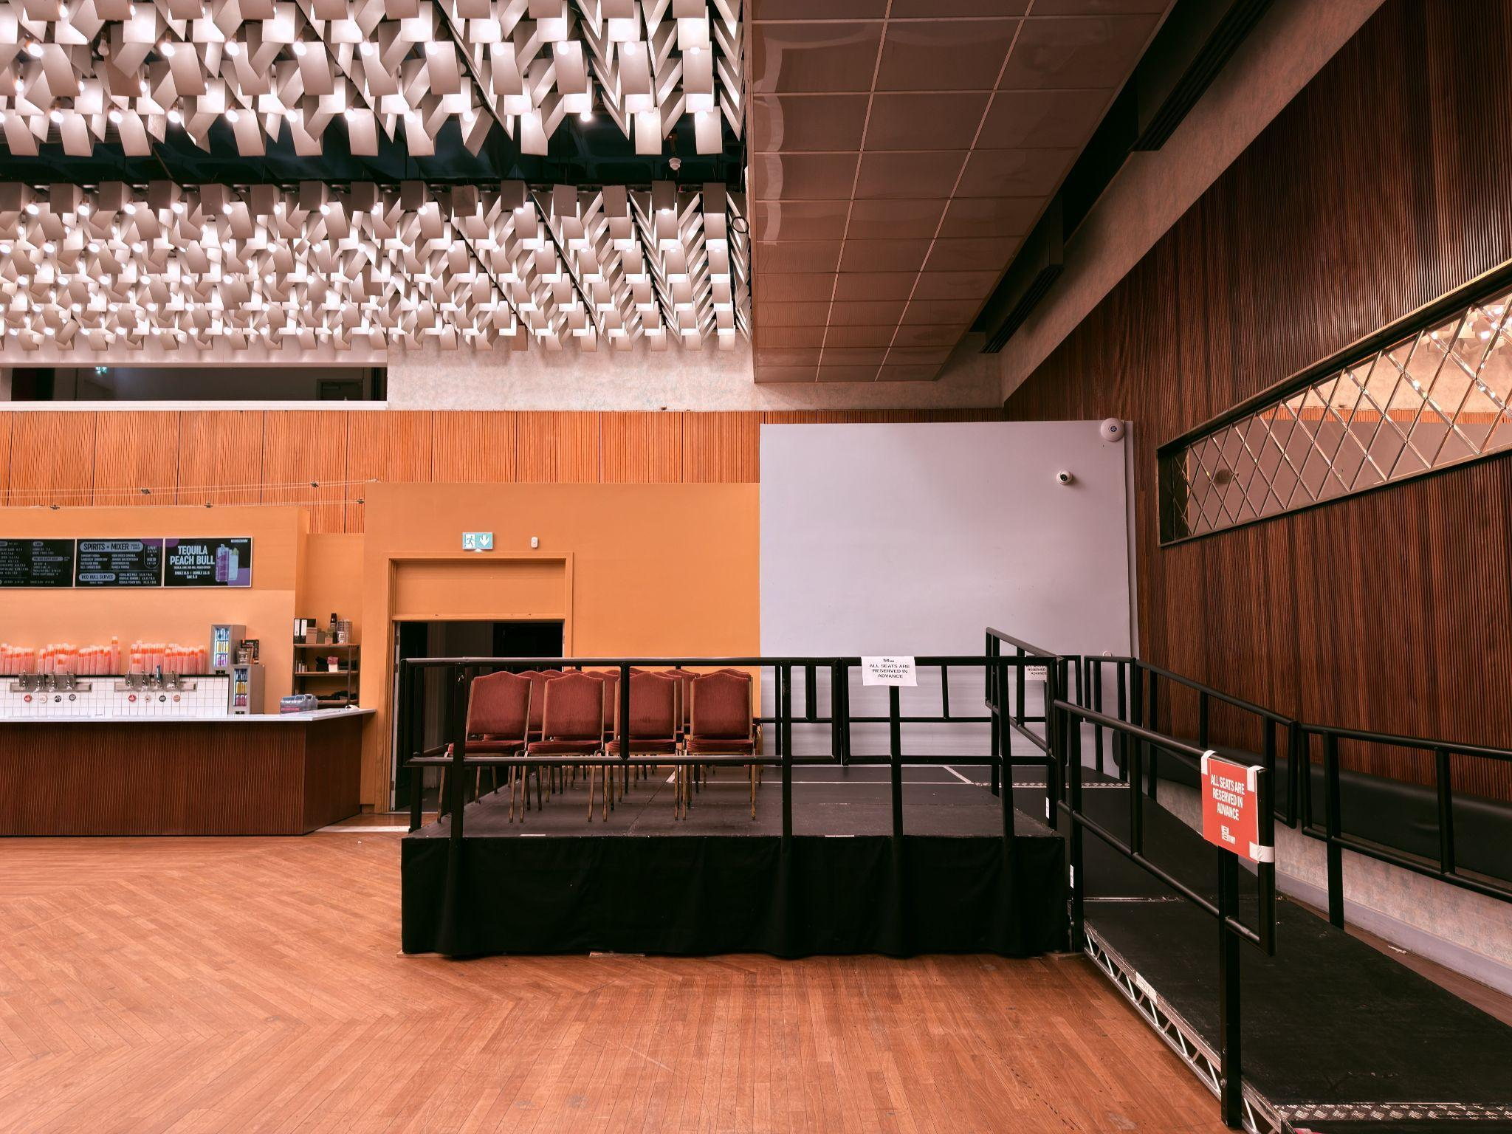
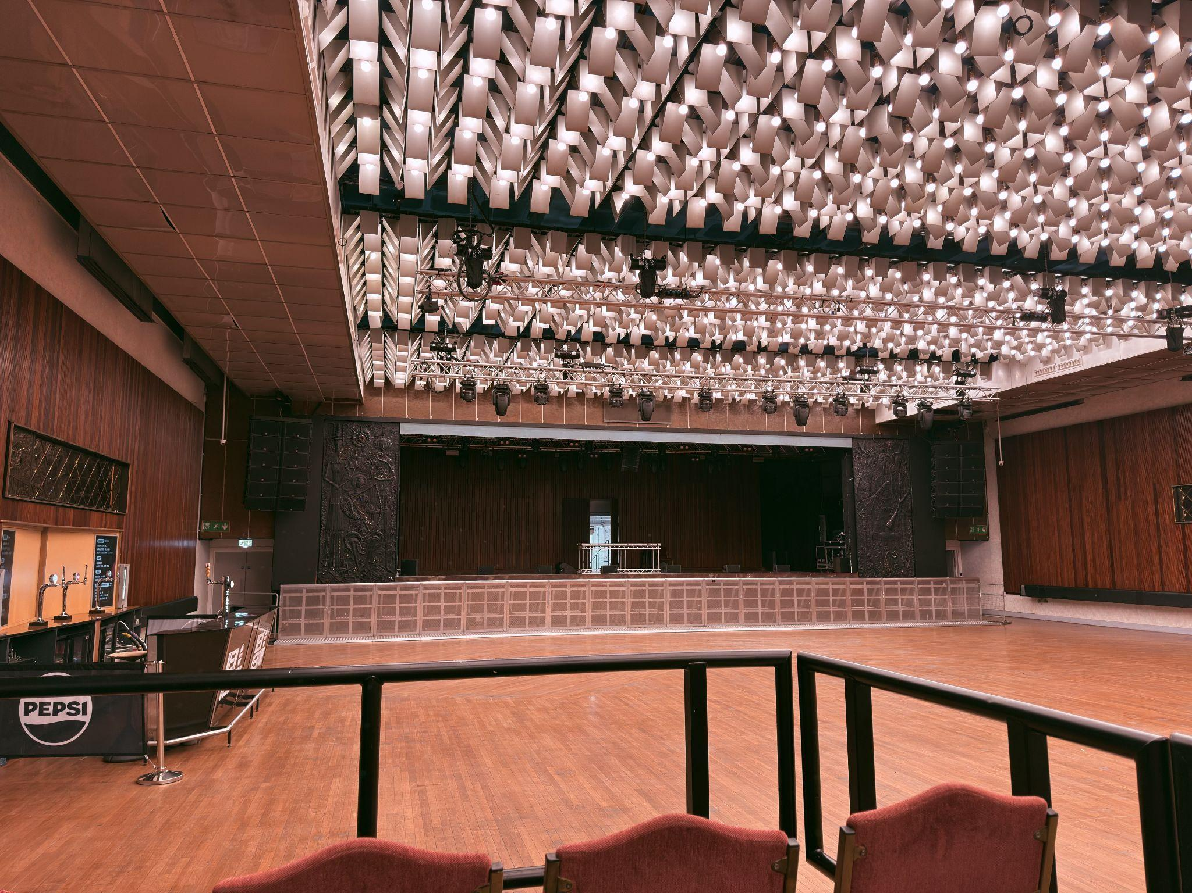

Access

New Century Hall is located on the first floor above New Century Kitchen.
You can reach the Hall by either:

- Two flights of stairs with handrails on both sides, or
- Lift access, which is suitable for wheelchair users.

The lift operates via staff key card, and a member of our team will be available to assist.
When you arrive, a member of staff will guide you to the access area, show you where the facilities are, and answer any questions you may have.

If you need to access the ground floor during the event, simply speak to a member of our bar staff or security, who will be happy to help you use the lift.

Arrival

To secure a good spot on the viewing platform, we recommend arriving just before doors open.
Doors typically open at 7pm, but please check your ticket provider’s website as times can sometimes change.

Set times are usually shared on our Instagram story on the day of the event.

When arriving at the venue, please head to the front of the queue outside the main entrance and let security know that you’re on the accessibility list. They will guide you to the box office, where a member of our team will assist you and bring you in ahead of the general admission queue.

Carer or Personal Assistant (PA) Ticket Information

Guests with accessibility requirements can request one free ticket for a personal carer or assistant.

To arrange this, please indicate it when completing the Access Requirements Form and provide proof such as a recent Access Card, DLA, PIP, or similar documentation.

We understand that some guests may require assistance but do not have formal documentation. If this applies to you, please contact us and we will review requests on an individual basis.

Carer tickets are offered on a first come, first served basis, depending on venue capacity and space within the access area.

Once we have the relevant information, we will send you a link to claim your free carer ticket. We will also notify our box office team, so they are aware when you arrive.

Please note that carers or personal assistants should be able to assist you in the event of an emergency.

Ticket Purchasing

Head to the events page on our website and find the event you would like to attend. From there, you can purchase one of our accessible tickets.

If you have already purchased a general admission ticket, we may still be able to accommodate you depending on availability. Please complete the Access Requirements Form or contact access@newcenturyhall.com, and we will let you know if space is available.

Please note that we are unable to refund carer tickets purchased in error, so when contacting the accessibility team it helps to have a screenshot or photo of your ticket purchase ready.

Wheelchair Spaces

Due to fire safety regulations, the venue can accommodate up to three wheelchair users per event.

These spaces are allocated on a first come, first served basis. If you require a wheelchair space, please note this in the Access Requirements Form or contact access@newcenturyhall.com.

We want everyone to be able to attend the shows they love and will always do our best to accommodate requests where possible.

Strobe Policy

Some shows may include strobe lighting, smoke machines, or other special effects as part of the production. Please let us know if you have any questions about this.

Disabled Parking

Unfortunately, we do not have on-site disabled parking, but there are several accessible parking spaces nearby within the city centre.

You can find nearby spaces using the following link:
https://www.manchester.gov.uk/site/scripts/directory_search.php?directoryID=54&postcode=M4+4AH

Customers with Medical Requirements

We welcome customers who may need to bring medicines, food, or drink to manage a medical condition, or medical equipment. Please contact us on access@newcenturyhall.com or 0161 834 1786 if you have any concerns or special requirements related to the above and we will assist however possible.

Accessibility FAQs

I have a general admission ticket — does that mean I have a seat?

New Century Hall is primarily a standing venue, so general admission tickets do not include a seat unless the event is advertised as fully seated.
If you have purchased a general admission ticket but require accessibility support, please contact us and we will check whether there is space available within the access area.

Can I bring my assistance dog?

Yes — guide and assistance dogs are welcome in both New Century Kitchen and the Hall.
If possible, please include this in your Access Requirements Form when booking an accessible ticket. You may be asked to sign a waiver accepting responsibility for your dog during the event.

I have an access question that isn’t listed here — what should I do?

If you have an accessibility query, please don’t hesitate to contact us at:
access@newcenturyhall.com

If your event is coming up soon and your request is urgent, you can also contact us at:
0161 552 6719

Phone lines are monitored Monday–Friday, 8am–4pm by our reception team. They’ll do their best to help or pass your query on to the management team.

If your event is further away, please allow up to one week for a response, as we receive a high number of enquiries and prioritise upcoming events.

Contact Us:

Email (preferred) – access@newcenturymcr.com - Managed by Stan
Phone – 0161 552 6719 - Reception
Postal – 34 Hanover Street, Manchester, M4 4AH

Response time – Someone will be able to respond within 7 days.

